Registration Number - 2025/CS/079
Index Number – 25000799
Temparory ID – 25001078

Part – B

Dialogue 01:

Command: pwd
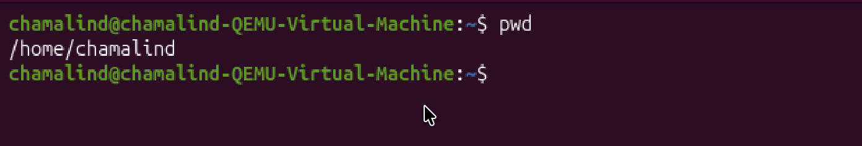

Dialogue 02:

Command: ls
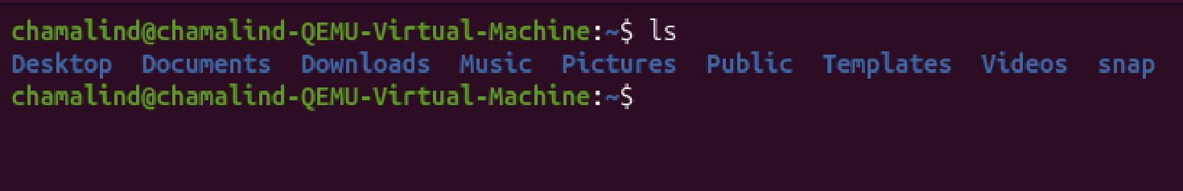

Dialogue 03:

Command: cd Desktop
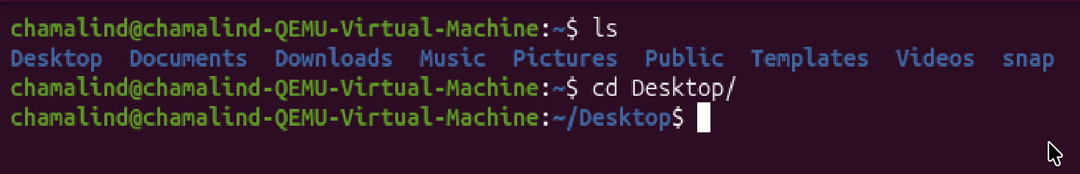

Dialogue 04:

Command: mkdir project_work

Dialogue 05:

Command: cd proejct_work

Dialogue 06:

Command: touch notes.txt

Dialogue 07:

Command: echo “Linux is powerful” > notes.txt

Dialogue 08:

Command: cat notes.txt

Dialogue 09:

Command: cp notes.txt notes1.txt

Dialogue 10:

Command: rm notes1.txt

Part – C

Dialogue 01:

Command: ls -a
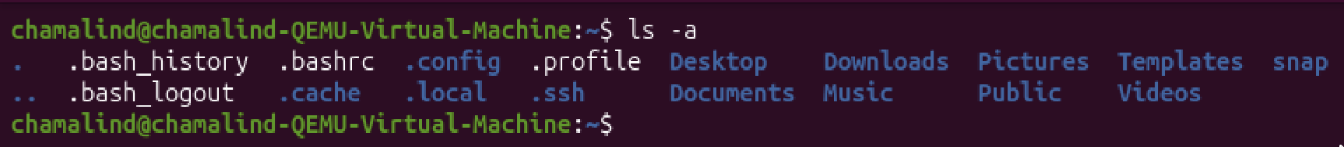

Dialogue 02:

Commands:
- cd Desktop
- mkdir project
- cd project
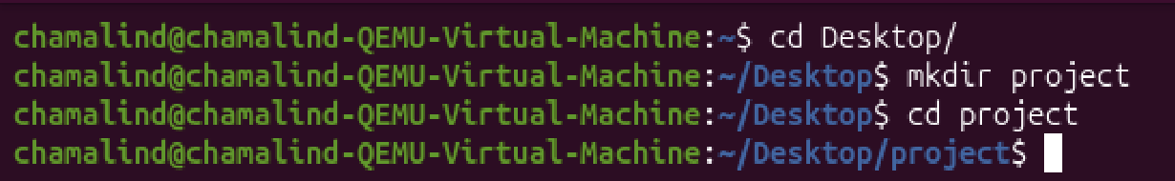

Dialogue 03:

Command: touch a.txt b.txt c.txt

Dialogue 04:

Command: ls -l
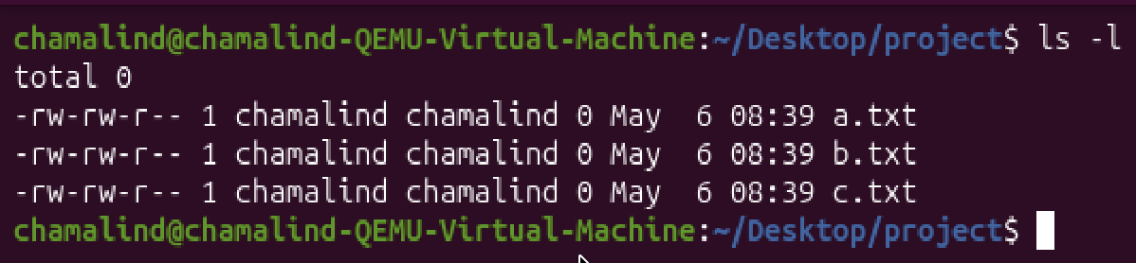

Dialogue 05:

Command: grep -i “apple” a.txt
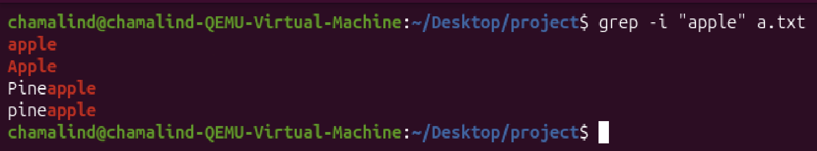

Dialogue 06:

Command: wc -l a.txt
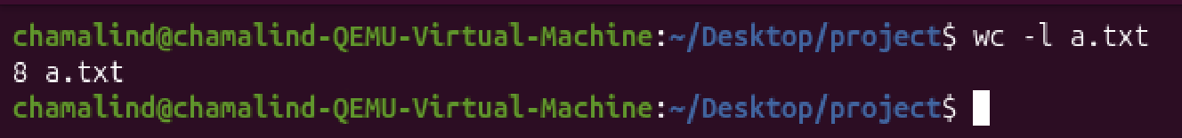

Dialogue 07:

Command: chmod a-w a.txt
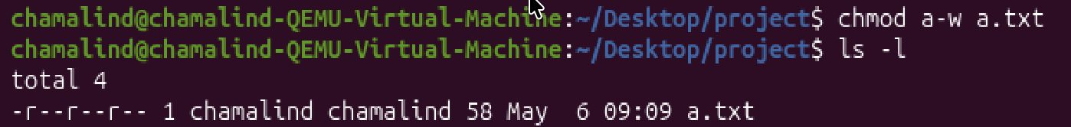

Dialogue 08:

Command: chmod +x a.txt
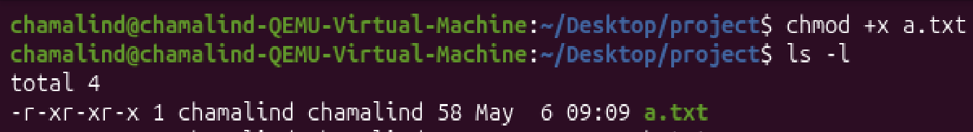

Dialogue 09:

Command: grep -c “banana” a.txt
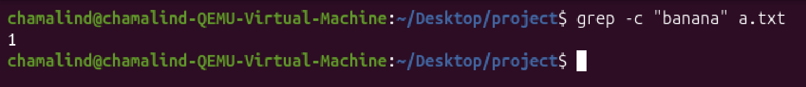

Dialogue 10:

Command: sort a.txt | uniq
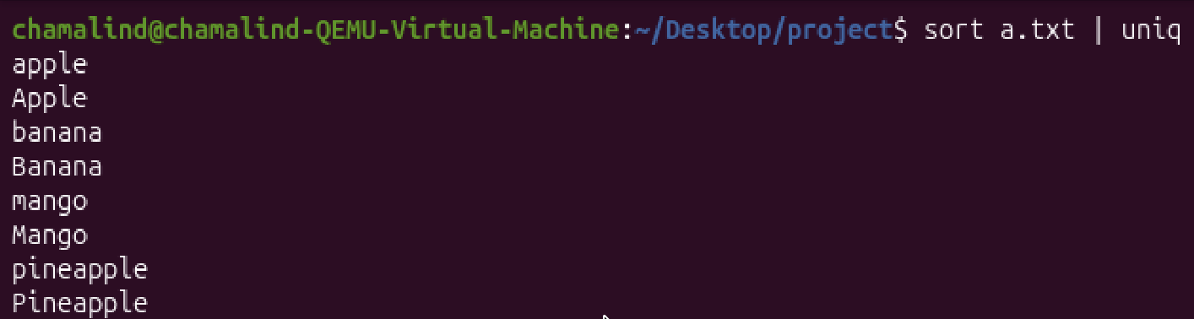

Dialogue 11:

Command: grep -v “apple” a.txt
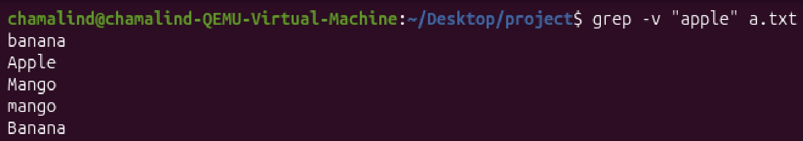

Dialogue 12:

Command: sort -r a.txt
